**Ethereal – MYTH**

**MYTH description**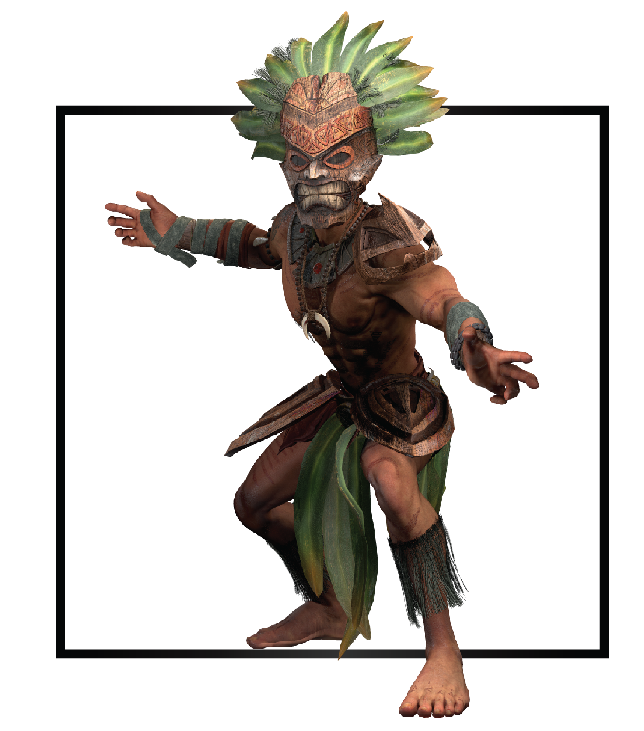

|  |  |
| --- | --- |
| **Name** | Chief Ikai’ka |
| **Title** | The Volcanic Core |
| **Realm** | Zuria |
| **Region** | Rainuki Islands |
| **Class** | Archmage |
| **Type** | Ranged Magical |
| **Release Date** | Coming Soon |

Tropical bright flowers covered a steep jungle slope. A scented trail surrounded by evergreen mats led to the volcano’s smoldering throat. Sweet scents of the fruit trees and nectar of foliage flooded the atmosphere, all together they encapsulated a never-ending bloom around the Rainuki Islands. Driven by turmoil, Chief Ikai’ka struggled to climb up the flower path, the core demanded a life as a sacrifice again.

Behind him, cracking fire consumed his village down to ashes. A couple of hours before, the angry volcano spat out an initial wave of igneous rocks, demons, and unquenchable flames. Now, more demons threatened to cross the portal into Zuria. The Rainuki people sentenced to an infinite cycle of death and fire.

Exhausted, Ikai'ka lowered his gaze to Kanju, the chief's council leader, who raised her voice above the chaos to direct efforts from incoming help. Islet villagers and warriors rushed from boats to counteract the raging fires and slay small abominations. A small but loving smile spread across Kanju's face when she met his eyes, aware of the uncertainty that lay beyond her dying husband’s path; she blew a kiss.

A powerful rumble turned Ikai’ka’s attention back to the volcano’s apex, with renewed courage he resumed the grueling ascent. Flowers imbued with spirits of previous chiefs urged him to continue by parting as he passed. His left hand pressed on an open gut wound, blood oozed down his leg leaving molted footprints and burning the flowers and soil like fresh lava.

Deformed appendages reached out the volcano’s mouth, a strangled cry screeched as claws grasped the rocks around in an attempt to free themselves from the relentless core. Ikai’ka broke into a run, forgetting all about the excruciating pain that tore his body apart. Time was running out…like many times before.

Far down, people gathered around boats as Kanju led them to safety from impending abominations. Ikai’ka noticed that it only a delay, no one left the Rainuki Islands; if he failed, their paradise would become their crypt. Familiar scents of sulfur and ashes greeted him as he approached the incandescent mouth of the volcano, razor claws continued to thrash around the edge. This creature bigger and stronger than ever before represented a new test to the core’s limit.

Ikai’ka in no condition to fight hand to hand peered inside the opening without fear. Leaving a sigh to carry out by the breeze, Ikai’ka let himself fall. Around him, spirits of nature, his ancestors, surrounded him in petals as winds bore his reluctant body. Ikai’ka dove into the lava as it surrendered like sea water. Satisfied for the sacrifice the core powered up to heal his wounds. Above, the demon emitted a cry of pain as the core sucked it into the depths of Kraxus.

Chief Ikai’ka unaware of how long he would stay inside the volcano this time closed his eyes. At least his people would be safe, and no innocent life would need sacrificing. The core, now satisfied, would be dormant; for the time being.